**CSA05: DATABASE MANAGEMENT SYSTEMS-ASSIGNMENT-2**

**Name : R.Sanjay vignesh**

**Reg num :192324061**

**Question 1: Top 3 Departments with Highest Average Salary**

**Write a SQL query to find the top 3 departments with the highest average salary of employees. Ensure departments with no employees show an average salary of NULL.**

CREATING TABLES :

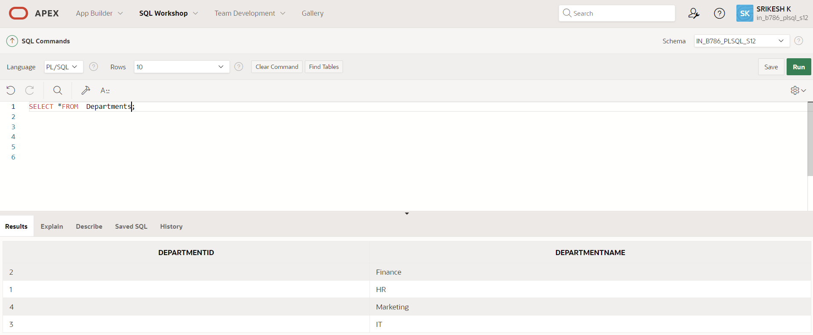

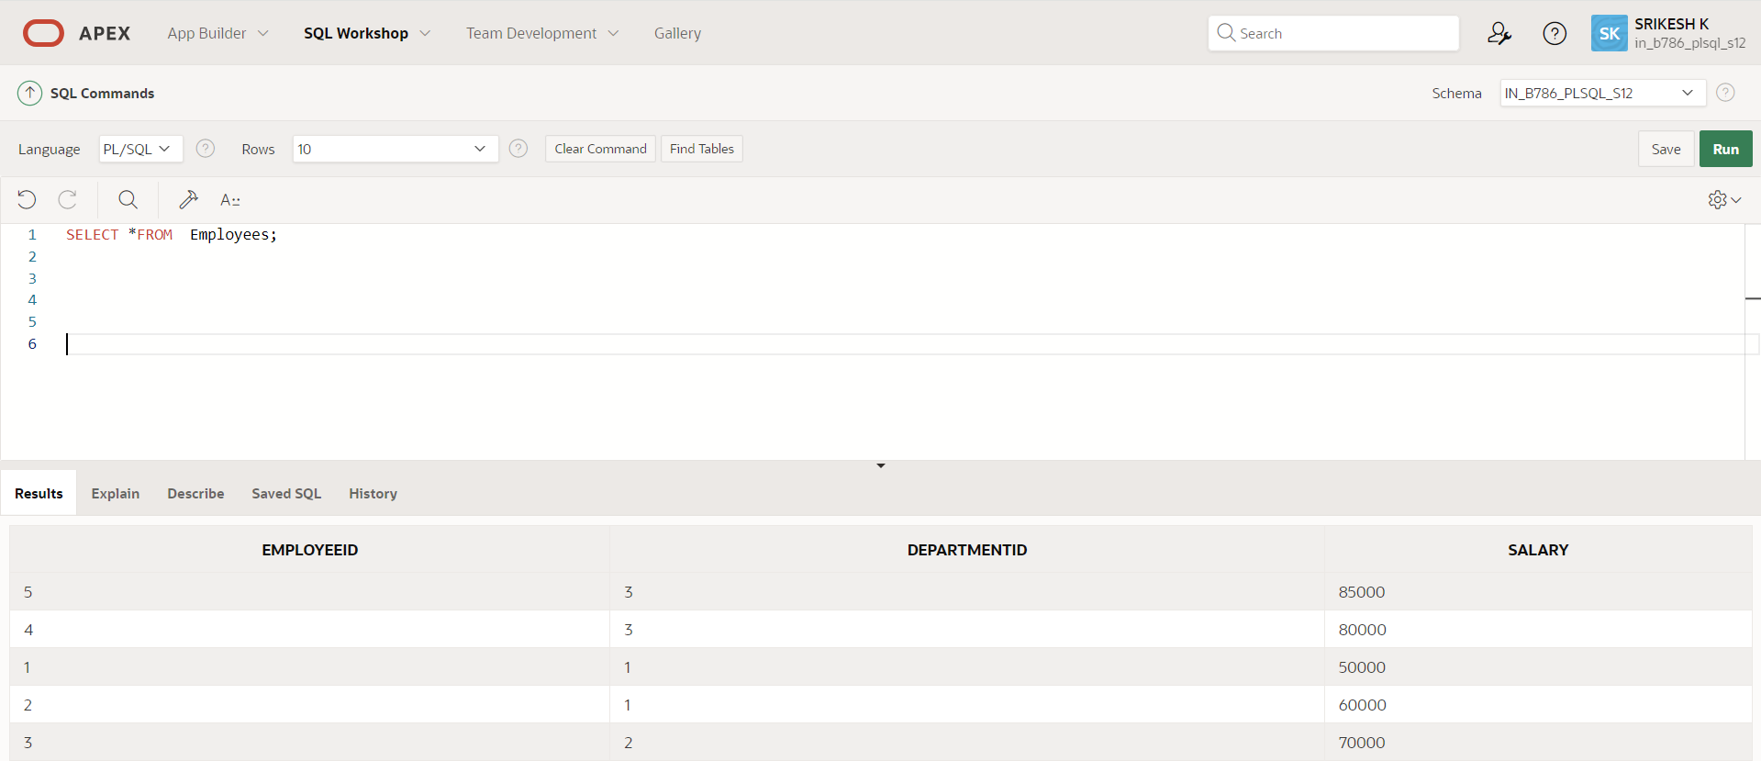

QUERY :

SELECT

d.DepartmentID,

d.DepartmentName,

AVG(e.Salary) AS AvgSalary

FROM

Departments d

LEFT JOIN

Employees e ON d.DepartmentID = e.DepartmentID

GROUP BY

d.DepartmentID, d.DepartmentName

ORDER BY

AvgSalary DESC

FETCH FIRST 3 ROWS ONLY;

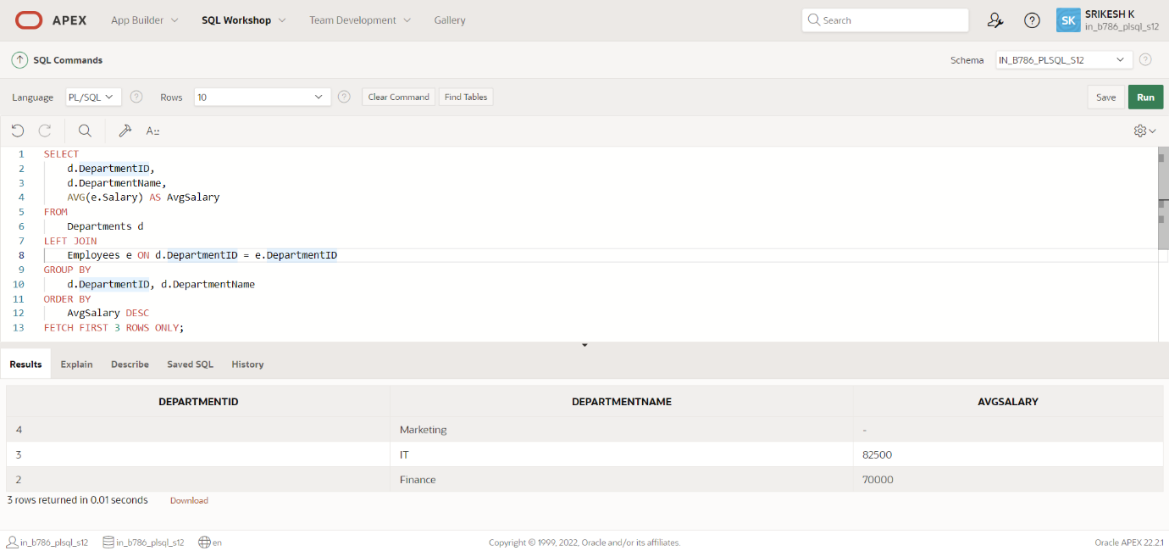

**Question 2: Retrieving Hierarchical Category Paths**

**Write a SQL query using recursive Common Table Expressions (CTE) to retrieve all categories along with their full hierarchical path (e.g., Category > Subcategory > Sub-subcategory).**

CREATING TABLE :

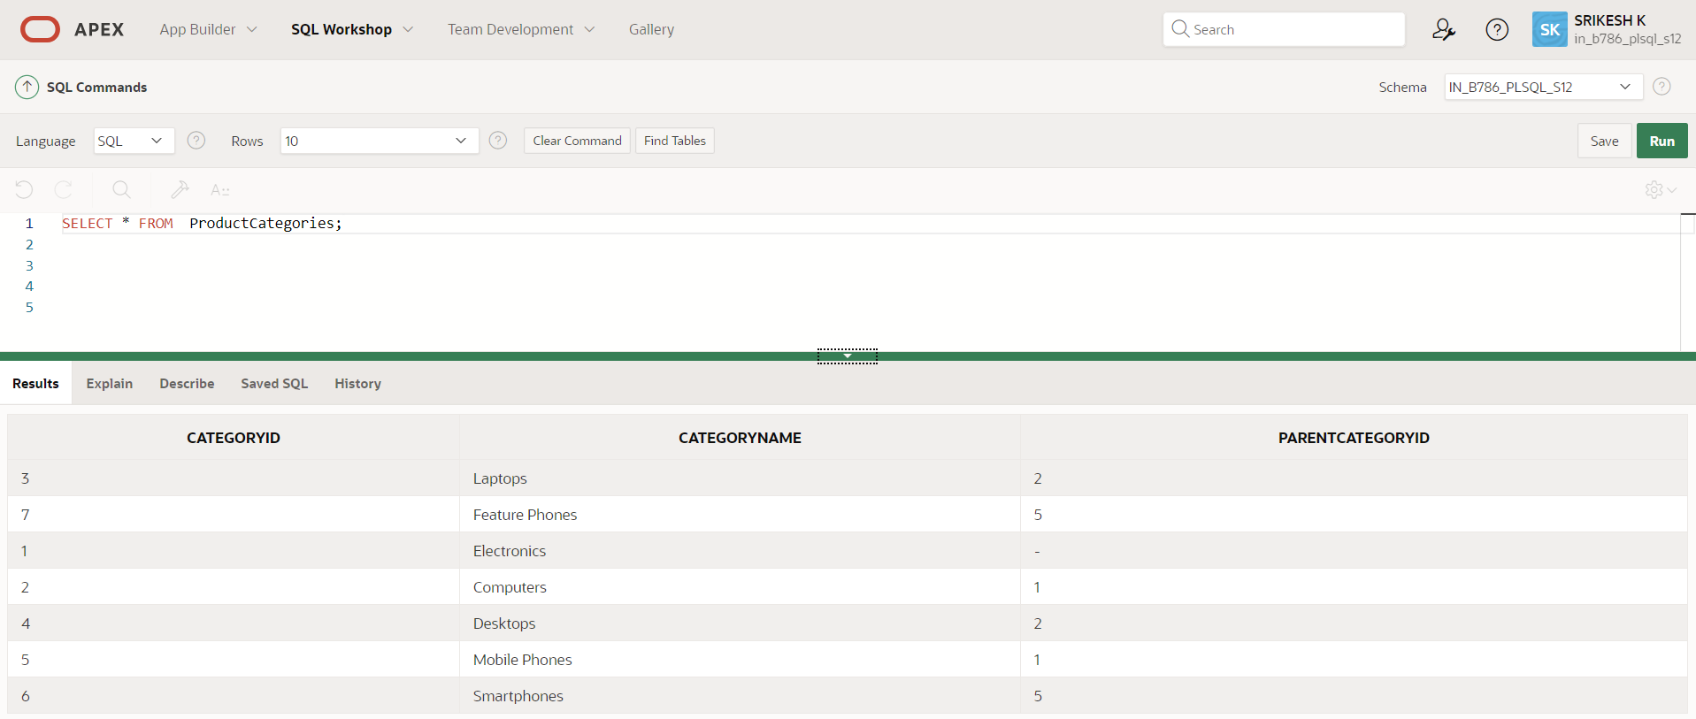

QUERY :

SELECT

CategoryID,

CategoryName,

SYS_CONNECT_BY_PATH(CategoryName, ' > ') AS HierarchicalPath

FROM

ProductCategories

START WITH

ParentCategoryID IS NULL

CONNECT BY

PRIOR CategoryID = ParentCategoryID

ORDER BY

HierarchicalPath;

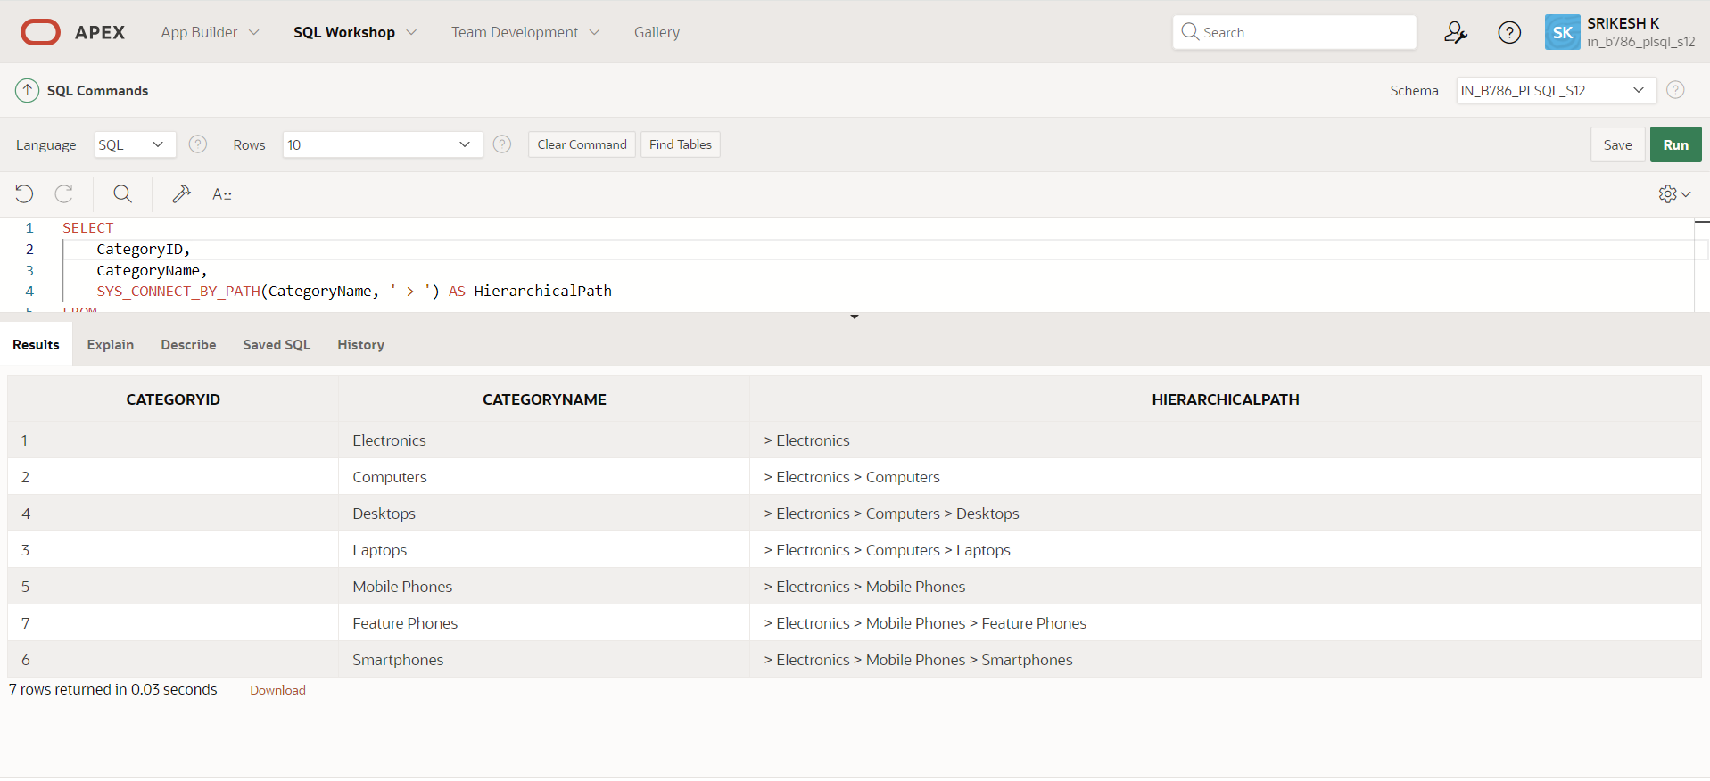

**Question 3: Total Distinct Customers by Month**

**Design a SQL query to find the total number of distinct customers who made a purchase in each month of the current year. Ensure months with no customer activity show a count of 0.**

CREATING TABLE :

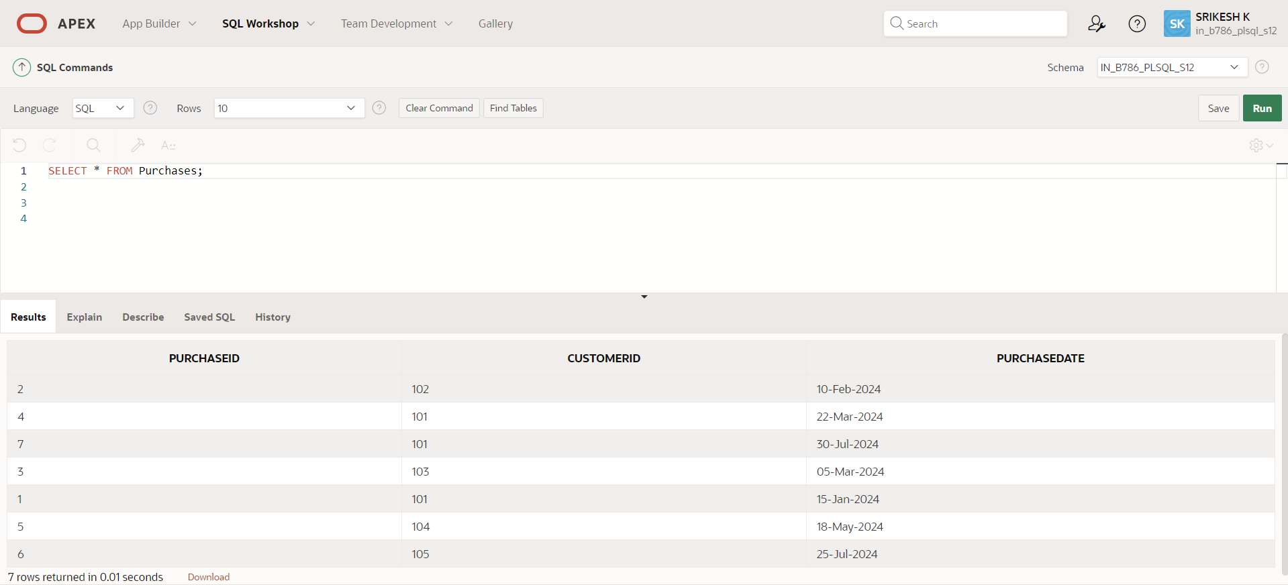

QUERY :

WITH Months AS (

SELECT TO_CHAR(ADD_MONTHS(TRUNC(SYSDATE, 'YEAR'), LEVEL - 1), 'Month') AS MonthName,

LEVEL AS MonthNumber

FROM DUAL

CONNECT BY LEVEL <= 12

),

CustomerCounts AS (

SELECT TO_CHAR(PurchaseDate, 'Month') AS MonthName,

COUNT(DISTINCT CustomerID) AS CustomerCount

FROM Purchases

WHERE EXTRACT(YEAR FROM PurchaseDate) = EXTRACT(YEAR FROM SYSDATE)

GROUP BY TO_CHAR(PurchaseDate, 'Month'), TO_CHAR(PurchaseDate, 'MM')

)

SELECT m.MonthName,

NVL(c.CustomerCount, 0) AS CustomerCount

FROM Months m

LEFT JOIN CustomerCounts c ON m.MonthName = c.MonthName

ORDER BY m.MonthNumber;

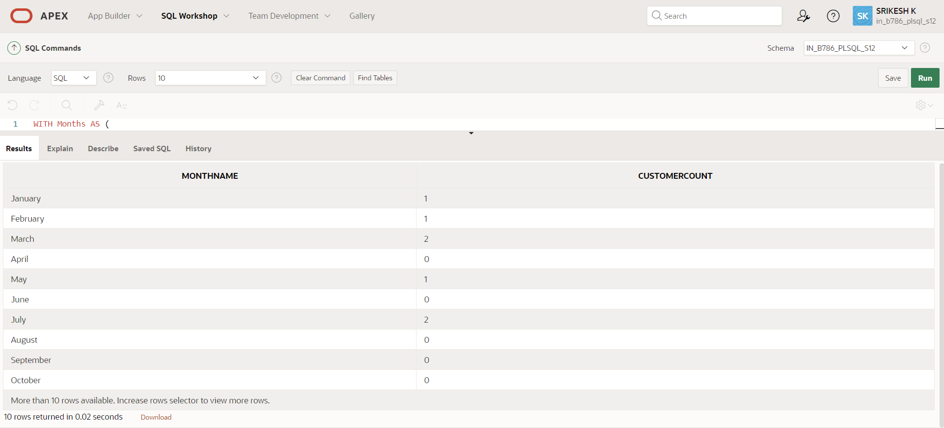

**Question 4: Finding Closest Locations**

**Write a SQL query to find the closest 5 locations to a given point specified by latitude and longitude. Use spatial functions or advanced mathematical calculations for proximity.**

CREATING TABLE :

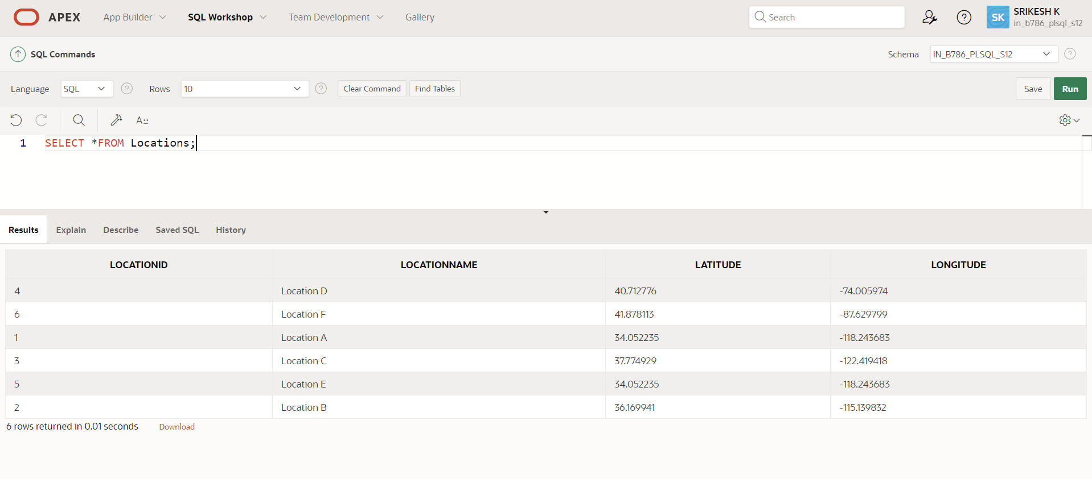

QUERY :

WITH input AS (

SELECT

34.052235 AS latitude,

-118.243683 AS longitude

FROM dual

)

SELECT *

FROM (

SELECT

loc.LocationID,

loc.LocationName,

loc.Latitude,

loc.Longitude,

(6371 * ACOS(

LEAST(1, GREATEST(-1,

COS(input.latitude * (3.141592653589793 / 180)) *

COS(loc.Latitude * (3.141592653589793 / 180)) *

COS(loc.Longitude * (3.141592653589793 / 180) - input.longitude * (3.141592653589793 / 180)) +

SIN(input.latitude * (3.141592653589793 / 180)) *

SIN(loc.Latitude * (3.141592653589793 / 180))

))

)) AS Distance

FROM

Locations loc, input

ORDER BY

Distance

)

WHERE ROWNUM <= 5;

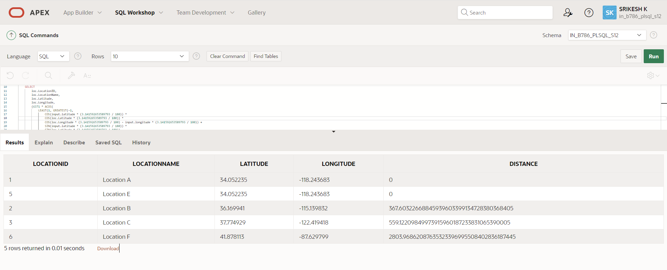

**Question 5: Optimizing Query for Orders Table**

**Write a SQL query to retrieve orders placed in the last 7 days from a large Orders table, sorted by order date in descending order.**

CREATING TABLE :

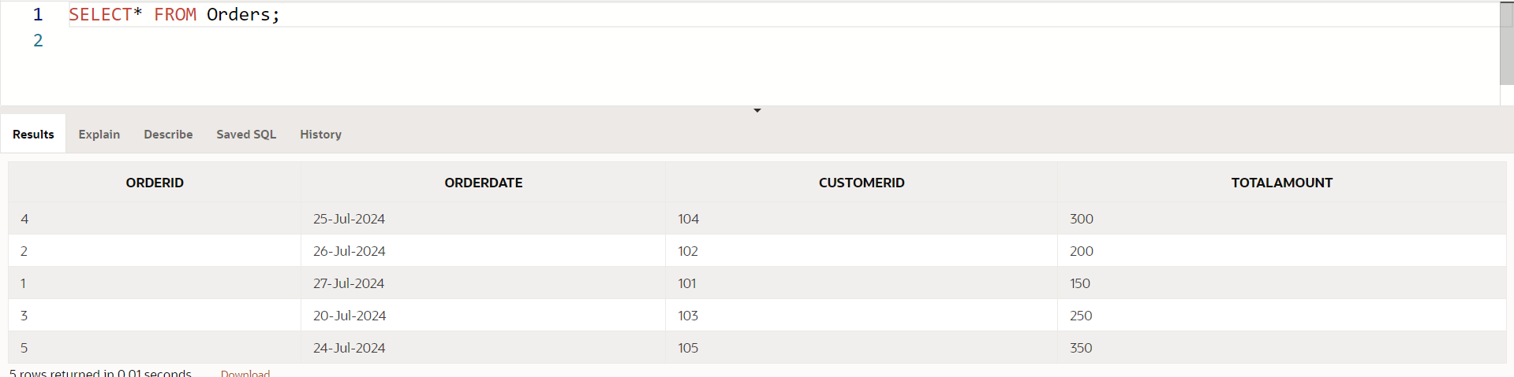

QUERY :

CREATE INDEX idx_orderdate ON Orders(OrderDate);

SELECT OrderID, OrderDate, CustomerID, TotalAmount

FROM Orders

WHERE OrderDate >= SYSDATE - 7

ORDER BY OrderDate DESC;

